Practice Exam Chapter 13

MULTIPLE CHOICE. Choose the one alternative that best completes the statement or answers the question.

1)

Economists generally define the short run as being
1)
_______

A)

that period of time in which all inputs are variable.

B)

any period of time less than six months.

C)

that period of time in which at least one of the firm's inputs, usually plant size, is fixed.

D)

any period of time less than one year.

2)

Which of the following is NOT a short-run decision for a manufacturing firm?
2)
_______

A)

Firing workers

B)

Hiring workers

C)

Downsizing the firm's manufacturing plant

D)

Investing in a new addition to the manufacturing plant

3)

During the short run, a firm cannot
3)
_______

A)

change its variable costs.

B)

increase its use of labor.

C)

purchase more raw materials.

D)

change its plant size.

4)

The long run is defined as the time-period in which
4)
_______

A)

the firm can vary only one input.

B)

the firm can make positive economic profits.

C)

the firm can alter its rate of production.

D)

all factors of production can be varied.

5)

Which of the following would be a fixed input for an amusement park?
5)
_______

A)

Concession workers
B)
Unpopped popcorn

C)

The roller coaster
D)
Ticket takers

6)

In economics, how long is the long run?
6)
_______

A)

24 months or longer

B)

More than 12 months

C)

5 years or more

D)

Whatever time it takes a firm to vary all inputs

7)

Production functions indicate the relationship between
7)
_______

A)

factor inputs and the quantity of output.

B)

factor costs and output prices.

C)

factor inputs and factor prices.

D)

the value of inputs and average costs.

8)

Which of the following statements is FALSE?
8)
_______

A)

The production function presents the technically efficient methods of combining inputs to produce output.

B)

The production function shows the technical relationship between a firm's inputs and outputs.

C)

Included in the firm's short-run production function are both fixed and variable inputs.

D)

An efficient firm can obtain more output than the production function shows.

9)

Which of the following WILL change a firm's production function?
9)
_______

A)

Acquiring additional physical capital

B)

Adopting new technology

C)

Hiring additional workers

D)

Adding a second production facility exactly like its first production site

10)

A negative value for the marginal physical product would indicate that
10)
______

A)

the company has not yet reached the point of saturation.

B)

total output decreased when the extra unit of the variable input was added.

C)

total output increased by a significant amount.

D)

total output increased, but the increase was very small.

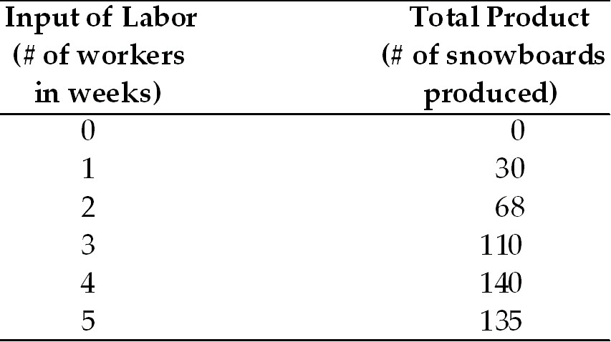

11)

In the above table, when the firm employs 4 workers, the marginal product will be
11)
______

A)

208 snowboards.
B)
30 snowboards.

C)

140 snowboards.
D)
35 snowboards.

12)

In the above table, diminishing marginal product occurs after employing the
12)
______

A)

second worker.
B)
fourth worker.

C)

third worker.
D)
first worker.

13)

In the short run, the additional output that results from hiring an additional unit of a variable input is the
13)
______

A)

marginal physical product.
B)
marginal cost.

C)

average variable cost.
D)
average product.

A firm has the following production relationship between labor and output, for a fixed capital stock.

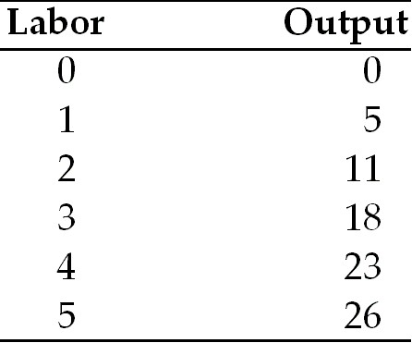

14)

According to the above table, what is the average product of labor when three laborers are employed?
14)
______

A)

3
B)
4
C)
5
D)
6

15)

The firm's short-run costs contain
15)
______

A)

only opportunity costs.
B)
only variable costs.

C)

only fixed costs.
D)
both variable and fixed costs.

16)

Which of the following is correct?
16)
______

A)

TC = FC + VC
B)
TC = FC / VC

C)

TC = FC - VC
D)
TC = FC * VC

17)

Suppose that when the level of output for the firm increases from 100 to 110 units, its variable costs increase from $500 to $700. What is the firm's marginal cost?
17)
______

A)

$20
B)
$200
C)
$7
D)
$5

18)

Which one of the following statements is FALSE?
18)
______

A)

MC = TC divided by Q
B)
TC = TFC + TVC

C)

AFC = TFC divided by Q
D)
ATC = AFC + AVC

19)

Assume it takes 10 units of labor to produce 4 units of output. When the price of labor is $6 per unit and fixed costs equal $60, what is the total cost of those 4 units of output?
19)
______

A)

$60
B)
$120
C)
$70
D)
$150

20)

In economics, a fixed cost is a cost that
20)
______

A)

goes up as the level of output goes up.

B)

does not vary with the level of output.

C)

goes down as the level of output goes up.

D)

is present only in the short run.

21)

Which of the following would NOT be considered a fixed cost of production?
21)
______

A)

Interest payments on a loan

B)

Insurance payments on plant and equipment

C)

Wages paid to labor

D)

The opportunity cost of capital

22)

When output is 100 units, the firm's total fixed cost is $500. What will this firm's total fixed cost be if output doubles to 200 units?
22)
______

A)

$500

B)

$1,000

C)

$250

D)

Can't tell from the information provided

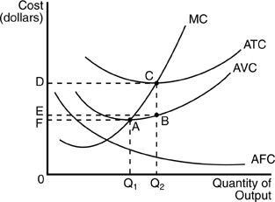

23)

In the above figure, if this firm produces output level Q2, it has average variable costs of
23)
______

A)

OE.
B)
OF.
C)
OC.
D)
OD.

24)

Marginal cost begins to rise when
24)
______

A)

fixed cost falls.

B)

diminishing marginal product begins.

C)

average total cost falls.

D)

diminishing marginal product ends.

25)

If the marginal product of an input factor is falling, then
25)
______

A)

average total cost is constant.

B)

marginal cost is falling.

C)

marginal cost is rising.

D)

average fixed cost is constant.

26)

The long-run average cost curve
26)
______

A)

is identical to the marginal cost curve.

B)

should always be horizontal.

C)

is a curve which is tangent to each member of a set of short-run average cost curves.

D)

is always a downward-sloping straight line.

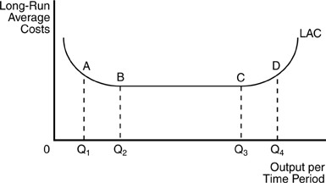

27)

In the above figure, for any output level less than Q2, this firm experiences
27)
______

A)

constant economies of scale.

B)

decreasing long run average costs.

C)

economies of scale.

D)

diseconomies of scale.

28)

Economies of scale exist where the long-run average cost curve is
28)
______

A)

tangent to the marginal cost curve.

B)

upward sloping.

C)

horizontal.

D)

downward sloping.

29)

Diseconomies of scale occur
29)
______

A)

only in the short run.
B)
because of fixed costs.

C)

only in the long run.
D)
none of the above.

30)

A horizontal long-run average cost curve indicates
30)
______

A)

constant marginal physical product.

B)

diseconomies of scale.

C)

constant returns to scale.

D)

economies of scale.

31)

When increasing its output results in falling costs, a firm that can adjust all inputs is experiencing
31)
______

A)

capital gains.
B)
diseconomies of scale.

C)

loss.
D)
economies of scale.

32)

Accounting costs represent
32)
______

A)

both sunk and future costs.

B)

explicit costs paid by the firm.

C)

long run costs only.

D)

opportunity costs.

33)

Implicit costs are measured by
33)
______

A)

actual expenses paid by the firm.

B)

comparing the compensation packages of the CEOs in the industry.

C)

total revenues minus total costs.

D)

the value of alternative uses of the resources used in production.

34)

The implicit cost incurred by a firm to use its resources to produce its output is the firm's
34)
______

A)

total cost.
B)
explicit cost.

C)

accounting cost.
D)
opportunity cost.

35)

Which is the best example of a firm's implicit costs?
35)
______

A)

The opportunity cost of owner-provided labor

B)

Taxes

C)

Wages

D)

Rent

36)

Economic profits equal
36)
______

A)

accounting profits.

B)

accounting profits plus the owner's labor opportunity costs.

C)

total revenue less the opportunity costs of all factors of production.

D)

accounting profits less economic rents.

37)

If the explicit costs to a firm to produce a unit of output are $6 and the firm sells 200,000 units of output for $9 per unit, the accounting profit received by the producer is
37)
______

A)

$1.2 million.
B)
$600,000.

C)

$1.8 million.
D)
$850,000.

38)

Suppose a family-owned yogurt shop has $80,000 in total revenues, $36,000 in rent, and $20,000 in additional operating costs. The husband and wife work in the shop and pay no wages to themselves or others. The economic profits from the shop are
38)
______

A)

more than $24,000.
B)
$24,000.

C)

less than $24,000.
D)
$80,000.

39)

Economic profits are equal to
39)
______

A)

total revenues, after tax, minus cost of goods sold.

B)

total revenues minus total fixed costs.

C)

total revenues minus the implicit and explicit costs of all inputs used.

D)

total revenues minus the opportunity cost of labor.

40)

Accounting profit is equal to
40)
______

A)

total revenue minus implicit costs.

B)

dividends paid.

C)

total revenue minus explicit costs.

D)

total revenue minus dividends and interest.

1)

C

2)

D

3)

D

4)

D

5)

C

6)

D

7)

A

8)

D

9)

B

10)

B

11)

B

12)

C

13)

A

14)

D

15)

D

16)

A

17)

A

18)

A

19)

B

20)

B

21)

C

22)

A

23)

A

24)

B

25)

C

26)

C

27)

C

28)

D

29)

C

30)

C

31)

D

32)

B

33)

D

34)

D

35)

A

36)

C

37)

B

38)

C

39)

C

40)

C

