Chapter 15 Monopoly Practice Exam

MULTIPLE CHOICE. Choose the one alternative that best completes the statement or answers the question.

1)

Monopoly producers face
1)
_______

A)

No competitive producers of the same product.

B)

Many competitors producing the same product.

C)

Only a few competitors producing the same product.

D)

At least one competitive producer of the same product.

2)

Which of the following statements is FALSE?
2)
_______

A)

An unregulated, profit-maximizing monopolist will not operate in the inelastic portion of the demand curve.

B)

A monopolist may have very close substitutes for the product produced by the firm.

C)

The marginal revenue earned by a monopolist will always be less than the product's price.

D)

For a profit-maximizing monopolist, marginal revenue equals marginal cost.

3)

If a monopolist wishes to increase its output and quantity sold,
3)
_______

A)

it must raise its price, so its marginal revenue is greater than its price.

B)

it must reduce its price, so its marginal revenue is less than its price.

C)

it must reduce its price, so its marginal revenue is greater than its price.

D)

it must raise its price, so its marginal revenue is less than its price.

4)

A firm can be the sole supplier of a good and still not be a monopoly if
4)
_______

A)

the good produced is not important to the economy.

B)

there are very close substitutes for the good.

C)

the firm is not large.

D)

the firm is not making excessive profits.

5)

In order for a firm to receive monopoly profits, there must be
5)
_______

A)

homogeneous products.

B)

mutual interdependence among firms.

C)

barriers to market entry.

D)

free entry and exit to the market.

6)

Which of the following are barriers to entry?
6)
_______

A)

Economies of scale
B)
Control of resources

C)

Patents and copyrights
D)
All of the above

7)

Which of the following is NOT a barrier to entry?
7)
_______

A)

Licenses
B)
Patents

C)

U.S. antitrust legislation
D)
Economies of scale

8)

Which of the following is NOT a barrier to entry that would allow the monopolist to keep potential competitors out of its market?
8)
_______

A)

The market price of the product is too high.

B)

Economies of scale are very pronounced.

C)

The firm has a patent on the good or control over some resource needed in the production of the good.

D)

The firm has government authorization to be a monopoly.

9)

Which of the following would NOT be a barrier to entry for a particular market?
9)
_______

A)

Ownership of a patent

B)

The presence of economies of scale

C)

Low cost of obtaining initial capital

D)

Government regulation

10)

If there are no barriers to entry into an industry,
10)
______

A)

short-run and long-run profits must still be positive.

B)

short-run economic profits must be zero.

C)

long-run economic profits must be zero.

D)

both short-run and long-run economic profits must be zero.

11)

A monopolist can earn economic profits in the long run because
11)
______

A)

a monopoly makes the good or service better than anyone else.

B)

barriers to entry prevent new firms from entering the industry.

C)

monopolies can legally force people to buy their products and to pay more for them than they are worth.

D)

a monopoly is by definition large, and this gives it the ability to make large profits.

12)

A natural monopoly usually arises when
12)
______

A)

there are diseconomies of scale in an industry.

B)

companies band together to form a cartel.

C)

the government allows unrestricted access to a market.

D)

there are large economies of scale relative to the industry's demand.

13)

Drug companies protect their monopolies over various drugs they develop by utilizing
13)
______

A)

patent protection.

B)

diseconomies of scale.

C)

low cost production.

D)

zero economic profits in the long run.

14)

A patent on a product gives a firm
14)
______

A)

protection from having the invention copied or stolen for a period of 20 years.

B)

economies of scale in producing the product.

C)

the power to impose a tariff on a competing product.

D)

excessive profits in the long run.

15)

Compared to perfectly competitive firms, the demand curve for a monopolist will be
15)
______

A)

less elastic.
B)
perfectly elastic.

C)

as elastic.
D)
more elastic.

16)

The demand curve facing the monopoly is
16)
______

A)

vertical.
B)
horizontal.

C)

upward sloping.
D)
downward sloping.

17)

Which of the following is true for a monopolist?
17)
______

A)

MR = AFC
B)
MR = P

C)

MR < P
D)
MR < AVC

18)

To sell one more unit of a good, a monopolist must
18)
______

A)

raise the price only on the last unit sold.

B)

lower the price on all units.

C)

lower the price on the last unit only.

D)

raise the prices on all goods.

19)

The demand curve faced by the pure monopolist
19)
______

A)

is the market demand curve.

B)

lies below the marginal revenue curve.

C)

is perfectly inelastic.

D)

is the same as its marginal revenue curve.

20)

To sell more units, a monopolist
20)
______

A)

can continue to receive the same price it always has as long as it has its customers' goodwill.

B)

simply moves across its horizontal demand curve to a larger quantity.

C)

moves down its demand curve to a lower price that will increase quantity demand.

D)

must be willing to lower the barriers to entry that have protected it.

21)

If a firm sells 10 units of output at $100 per unit and 11 units of output when price is reduced to $99, its marginal revenue for the last unit sold is
21)
______

A)

$109.
B)
$89.
C)
$11.
D)
$99.

22)

If a firm sells 5 units of output at $10 per unit and 6 units of output when price is reduced to $9, its marginal revenue from selling the sixth unit is
22)
______

A)

$4.
B)
$40.
C)
$540.
D)
$9.

23)

The demand curve facing a monopolist will be more elastic
23)
______

A)

as the consumers' need for the good increases.

B)

the greater the amount of fixed costs to cover.

C)

the greater the number of substitute products.

D)

as the number of consumers increases.

24)

For a monopolist that is maximizing profits,
24)
______

A)

price equals average total cost.

B)

price exceeds marginal cost.

C)

marginal revenue exceeds price.

D)

price equals marginal revenue.

25)

The monopolist will choose the price and output combination at which
25)
______

A)

MC equals MR.
B)
MR equals AR.

C)

MC equals price.
D)
MC equals AR.

26)

Suppose a monopolist's costs and revenues are as follows: ATC = $45.00; MC = $35.00; MR = $35.00; P = $45.00. The firm should
26)
______

A)

decrease output and increase price.

B)

not change output or price.

C)

increase output and decrease price.

D)

shut down.

27)

Suppose a monopolist's costs and revenues are as follows: ATC = $50.00; MC = $35.00; MR = $45.00; P = $55.00. The firm should
27)
______

A)

shut down.

B)

increase output and decrease price.

C)

decrease output and increase price.

D)

not change output or price.

28)

The profit maximizing behavior of a monopoly is different from that of a perfectly competitive firm in that a monopoly can
28)
______

A)

control the position of its demand schedule, but a competitive firm cannot.

B)

control the desired price and output to maximize profits, but a perfectly competitive firm can only choose the desired output.

C)

only choose the desired price, while a competitive firm can control only output.

D)

only choose the desired output, while a competitive firm can control only price.

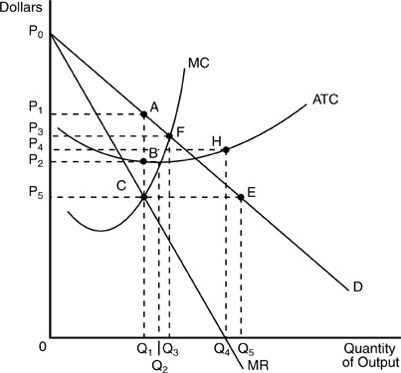

29)

The profit-maximizing price and quantity established by the unregulated monopolist in the above figure are
29)
______

A)

Q4 units of output and a price of P4.

B)

Q3 units of output and a price of P3.

C)

Q1 units of output and a price of P1.

D)

Q1 units of output and a price of P5.

30)

In the above figure, at the firm's profit maximizing output, total revenue is rectangle
30)
______

A)

0P1AQ1.
B)
0P3FQ3.
C)
0P2BQ1.
D)
0P5EQ5.

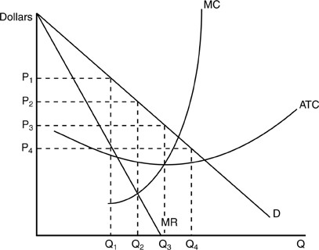

31)

In the above figure, if the firm is producing at Q3 and charging a price of P3, it should
31)
______

A)

shut down.

B)

decrease output and increase price.

C)

increase output and decrease price.

D)

not change output or price.

32)

In the above figure, if the firm is producing Q1 units at a price P1, the firm should
32)
______

A)

shut down.

B)

increase output and decrease price.

C)

not change output or price.

D)

decrease output and increase price.

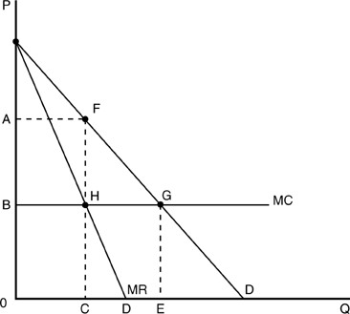

33)

In the above figure, the monopolist's profit-maximizing output level is
33)
______

A)

A.
B)
B.
C)
C.
D)
D.

34)

Profits can be maximized by equating MR = MC = Price,
34)
______

A)

only in monopoly markets.

B)

only in perfectly competitive markets.

C)

only in discriminating monopoly markets.

D)

only with government price controls.

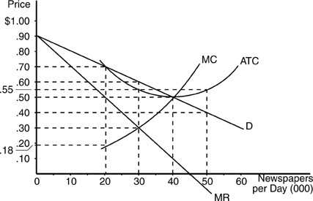

35)

According to the above figure, the profit maximizing price-output combination for the monopolist is a price of
35)
______

A)

50 cents and an output of 40,000 newspapers per day.

B)

60 cents and an output of 30,000 newspapers per day.

C)

45 cents and an output of 45,000 newspapers per day.

D)

30 cents and an output of 30,000 newspapers per day.

36)

With price discrimination a monopolist will
36)
______

A)

charge a higher price when marginal cost is lower.

B)

charge a lower price to consumers whose demand is more elastic.

C)

no longer have a downward-sloping demand curve.

D)

charge a higher price to consumers whose demand is more elastic.

37)

According to the above figure, the maximum profit the monopolist can receive is
37)
______

A)

$9,000 per day.
B)
$7,500 per day.

C)

$1,500 per day.
D)
0.

38)

According to the above figure, what are the profits of the firm if it produces 50,000 units?
38)
______

A)

-$5,000 per day
B)
-$17,500 per day

C)

-$10,000 per day
D)
-$7,500 per day

39)

A profit-maximizing monopolist earns an economic loss whenever
39)
______

A)

the price it charges for its product exceeds average total cost.

B)

it pays taxes to the government on each unit of output it produces.

C)

it produces along the elastic portion of a demand curve.

D)

the demand curve lies completely below the ATC curve.

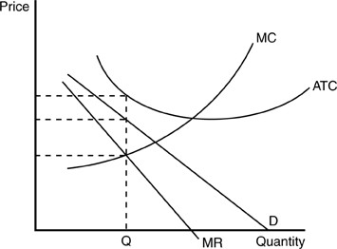

40)

If the above figure accurately portrays the market conditions for a given monopolist, we can be assured that the monopolist
40)
______

A)

will be forced to go out of business in the long run.

B)

is producing at the level that will maximize benefit to society.

C)

is making a normal profit.

D)

is a part of a cartel.

41)

Price discrimination refers to
41)
______

A)

charging the same prices to all consumers but selling them different quantities.

B)

selling a product at different prices, with the price difference being unrelated to differences in marginal cost.

C)

selling a product at different prices according to the differences in marginal cost of providing it to different consumers.

D)

a deliberate effort on the part of a monopoly producer to confuse consumers.

42)

A monopolist sells a homogeneous good in several distinct submarkets, and the elasticities of demand differ in these submarkets. If the monopolist selects the rate of output to sell in each submarket by equating marginal revenue and marginal cost, then
42)
______

A)

it is not price discriminating, but merely price differentiating.

B)

customers in markets with more elastic demand will pay lower prices than customers in markets with less elastic demand.

C)

customers in markets with more elastic demand will pay higher prices than customers in markets with less elastic demand.

D)

all customers in all markets end up paying the same price.

43)

If different markets for a product produced by a monopolist can be separated and if the elasticity of demand differs between the two markets, then the monopolist will
43)
______

A)

be able to make higher profits by using price discrimination.

B)

charge a single price in all markets.

C)

sell the product in only one of the markets with inelastic demand curves.

D)

go out of business.

44)

Monopolies are discouraged in the United States because
44)
______

A)

they are more efficient than other industries.

B)

they hire too many workers.

C)

they can produce at lower cost in the short run.

D)

they restrict output and boost prices.

45)

Compared to an efficient perfectly competitive industry, the monopolist will
45)
______

A)

produce less output at a higher total cost.

B)

produce more output at a lower price.

C)

produce less output and charge a higher price.

D)

produce more output at a higher price and higher profit.

46)

Government policy that attempts to prevent collusion among the sellers of a product and attempts to prevent restraint of trade is known as
46)
______

A)

social policy.
B)
goodwill policy.

C)

inherent policy.
D)
antitrust policy.

1)

A

2)

B

3)

B

4)

B

5)

C

6)

D

7)

C

8)

A

9)

C

10)

C

11)

B

12)

D

13)

A

14)

A

15)

A

16)

D

17)

C

18)

B

19)

A

20)

C

21)

B

22)

A

23)

C

24)

B

25)

A

26)

B

27)

B

28)

B

29)

C

30)

A

31)

B

32)

B

33)

C

34)

B

35)

B

36)

B

37)

C

38)

D

39)

D

40)

A

41)

B

42)

B

43)

A

44)

D

45)

C

46)

D

